Appendices

Appendix 1

Public consultation
Consultation took place during 2011/2012 via online and hard copies of survey questionnaires, designed to assess the views of the residents, their attitude and aspirations concerning green spaces throughout the borough. The survey was advertised in the local press, the local “contacts” magazine distributed to every household in the borough, on the council website and internally, within the council. It was also advertised through the Leisure Services email bulletin which holds a database of over 6,000 leisure cardholders. Paper questionnaires were made available at Gedling Borough Councils One-Stop reception, at each of the five leisure centres and distributed to local libraries. A total of 424 surveys were returned, providing a substantial statistical evidence base. Residents were asked their views and opinions on green spaces and sports facilities in the borough in terms of quality, quantity and accessibility.

Demographics from respondents

When analysing the data from the public consultation, it was important to take into account the demographics of the respondents and compare this to the population profile of residents in the borough. Due to the nature of the survey, there was a noticeable difference between the demographics of the respondents and the population profile of Gedling and hence, this was taken into account when analysing the results, providing evidence for why consultation with children and young people was conducted as a separate survey.

The majority of respondents were female (61%), between the ages of 30 and 44 years of age (35%). Only 0.2% of responses were from those under the age of 16 and 1.2% of respondents were between the ages of 16 to 24. In fact, 66% of respondents were aged between 30 and 59. 87% described their ethnic origin as White British and 3% as White Irish/other, an ethnicity profile that falls broadly in line with the borough’s population statistics, however there were a higher proportion of female respondents than the borough’s profile.

Frequency of visits by typology

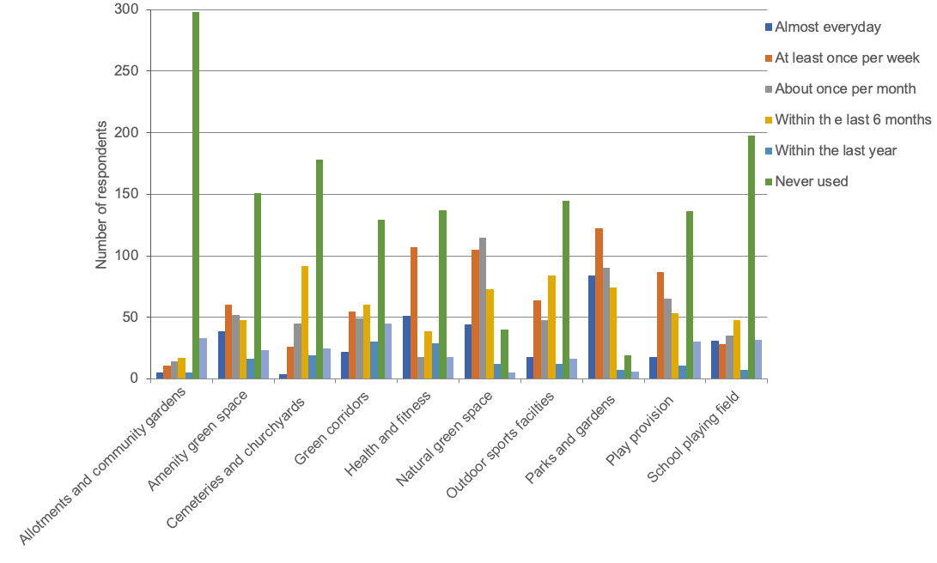
Natural and semi-natural green space

Four typologies stand out as the most frequently used (on a daily/weekly basis), these are parks and gardens and natural and semi-natural green space. Of the respondents, the least used facilities were allotments and community gardens and cemeteries and churchyards.

Most common mode of transport used to reach green spaces in Gedling

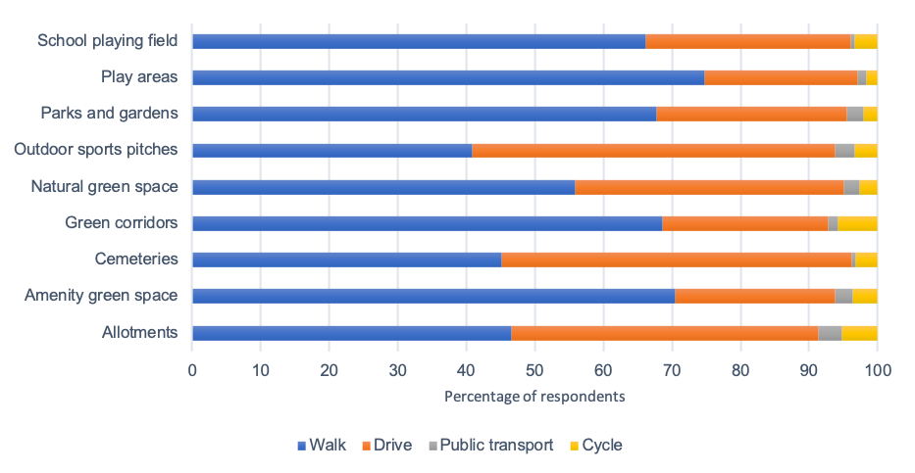
The most common mode of travel to green space facilities in the borough is by walking and driving. It is interesting to note that significantly more people walk to parks and gardens, natural green space, amenity green space, provision for children, school playing fields and green corridors than drive. Driving is more popular than walking when travelling to cemeteries, outdoor sports facilities and indoor facilities such as swimming pools, sports halls and gyms. Alternative modes of transport including public transport and cycling account for between 0% and 5% within each typology.

Travel times

Residents were asked to identify the travel times they considered as acceptable to the various typologies of green space.

Acceptable travel times and travel modes to green space typologies as identified by the borough’s residents
Green Space Typologies | Mode of Travel | Average Travel Time  (minutes) | Equivalent Distance Walking (metres)
Parks and Gardens | Walk | 15 | 1210
Amenity Green Space | Walk | 8 | 640
Provision for Children and Young People | Walk | 10 minutes for a local children’s play area  15 minutes for an informal play area | 800  1210
Natural and semi-natural green space | Walk | To a 2ha site: 15  20ha site: 34 | 1210  2740
Outdoor Sports Facilities | Walk  Drive | 10  15 | 800  9660
Allotments and community gardens | Walk  Drive | 20  10 | 1610  6,440
Cemeteries and churchyards | Drive/Walk | 20 | Walk: 1610  Drive: 12870
Green corridors | N/A | N/A | N/A
Equivalent distances have been calculated the nearest ten

The table above provides details of reasonable travel times and their preferred mode of transport to green spaces as identified by respondents. The expected travel time was calculated to the top 75 percentile in line with PPG17 guidance. Respondents were asked if the time it takes to travel to each typology was acceptable. Overall, 97% of respondents felt that the travelling time was acceptable. In addition to this, respondents were asked if there were sufficient publicly accessible green spaces in the borough, of which 79% thought there were and 16% thought there were not.

Quality

Local residents were asked to rate the quality of facilities using the descriptions – very good, good, average, poor and very poor. The graph below summaries the responses of those who use the facilities.

Perceptions of quality of green spaces
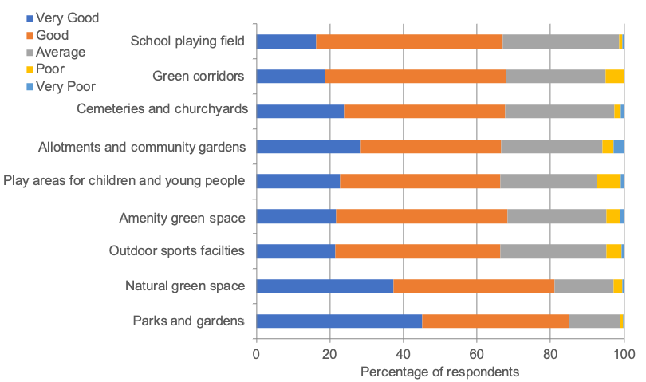

The general opinion of residents in the borough is that the quality of green spaces on the whole is good across all typologies other than parks and gardens which were rated as very good. The worst performing green spaces were school playing fields and outdoor sport facilities. Although these were rated as good, they had a lower average rating than other outdoor typologies. In addition to the public consultation, consultation took place on Parks and other green spaces as part of the Place Survey. In 2019, 73% of residents were satisfied with parks and green spaces in Gedling. Local residents were also asked to rate some factors on the sites they visited the most. The table below shows respondents responses to these factors:

Quality ratings of specific aspects of green spaces in the borough
 | Very Good | Good | Average | Poor | Very poor | No opinion
Standard of cleanliness | 18.9% | 47.9% | 24.8% | 3.8% | 0.9% | 0.7%
Design and appearance | 12.7% | 48.1% | 30.2% | 3.1% | 0.7% | 0.9%
Visitor facilities | 8.5% | 32.5% | 40.1% | 7.1% | 0.9% | 5.9%
Children and young people’s facilities | 11.8% | 36.8% | 25.7% | 4.5% | 0.9% | 13.7%
Outdoor sports facilities | 11.6% | 39.9% | 25.7% | 3.3% | 0.7% | 12.5%
Range of wildlife | 14.9% | 34.2% | 29.0% | 5.2% | 0.9% | 8.7%
Access around the sites | 17.9% | 48.6% | 22.6% | 0.9% | 0.2% | 4.5%
Choice and range of facility across the borough | 7.8% | 20.8% | 12% | 1.7% | 0.2% | 1.9%

The majority of respondents rate the facilities within the borough’s green spaces as good. Cleanliness was the highest rated aspect, with 66.8% of respondents rating it as either good or better. Access around the sites was also considered positively with 66.5% considering it as either good or better. Visitor facilities had the worse ratings with 7.1% considering the visitor facilities as poor.

Why people visit green spaces in the borough

Local residents were asked the reasons why they visited public green space in the borough. The top four reasons given were to go for a walk, to relax, to improve health and to take the family. Additionally, residents were asked about barriers to visiting public green space. The most common reasons given as a barrier for use were dog fouling (14%), quality of facilities (8%) and lack of facilities (7.5%). It is interesting to note that those barriers high up the agenda are related to quality and those quoted less regularly are related to access e.g., too many roads to cross (1.2%) limiting long term illness (0.9%), no one to go with (1.7%)

Local residents were also asked to rate some specific factors on the sites they visited the most. The table below shows respondents responses to these factors. The table shows that “dog fouling and litter” are seen as the biggest issues.

Rating of specific issues on open spaces in the borough
 | A very big problem | Significant problem | A fairly big problem | Significant problem | Occasional problem | Not a very big problem | No Problem | No opinion
Vandalism & Graffiti | 3.1% | 6.8% | 12.3% | 6.8% | 42.7% | 21.9% | 7.3% | 3.1%
Litter Problems | 5.2% | 13.9% | 12% | 13.9% | 36.3% | 20.3% | 7.8% | 0.9%
Anti-social behaviour | 4% | 4.7% | 11.6% | 4.7% | 38.2% | 20.5% | 14.9% | 3.1%
Dog fouling | 8.5% | 15.8% | 12% | 15.8% | 34.4% | 17.9% | 5.9% | 1.9%

Door to Door Survey

In January 2011, 470 respondents were interviewed from a sample of 500 during a door-to-door survey of residents. Residents were asked questions concerning parks and green spaces across the borough and leisure centres and community centres. The results complement the more recent public survey described above. This door-to-door survey provides additional information on:

- The profile of residents that use parks and open spaces in the borough
- Why people use the parks
- Reasons why parks are not used more often
- Parks people avoid using and reasons
- The feeling of safety in the parks
- What would improve safety in parks

Please note: The survey did not classify parks and greens spaces into the LPD20 typologies. Parks and green spaces play provision and outdoor sports facilities were included in what was defined as a park for the survey.

Demographics from respondents

When analysing the data from the door-to-door survey, it was important to account for the demographics of the respondents in comparison to the profile of the borough. Due to the nature of the survey, it was possible to collect data from residents that reflected the profile of the borough. The door-to-door survey showed that the majority of families with dependent children use their local parks and playing fields at least weekly and lone adults are least likely to use them. 46% of people between 25-44 use parks and playing fields on a weekly basis. After 45 years of age, the older the person is, the frequency of visits to these facilities reduces.

Reason for visiting the Parks

The door-to-door survey revealed some differences in the reasons why people use the parks in comparison to the public consultation. For example, the door-to-door survey highlighted people use the parks mainly for children’s play and walking. Although public consultation highlighted children’s play as relatively popular, it was not the most prevalent reason as to why people visited the parks on a weekly basis. However, it must be taken into account that a higher proportion of respondents from the public consultation were over 45 and hence less likely to have dependent children. From public consultation, other reasons why residents visit on a regular basis are for going for walks.
Reason why parks are not used more frequently | Percentage of respondents
Time | 30%
Health/age/disability | 18%
No children living at home | 13%
Prefer country walks | 10%
Lack of interest | 8%
Transport/Distance | 5%
Anti-social behaviour | 4%
No dogs | 4%
Weather | 3%
Travel to other local authority areas instead | 2%
No one to go with | 2%
Dog fouling | 1%

Those surveyed were asked if there were any reasons why they do not use the parks more often. The most common reason why people do not use the parks more frequently was due to personal time constraints and the second most common was due to health, age and disability. 13% of people felt that because children were not living at home there was not a strong enough reason to visit the parks. The public consultation showed that dog fouling and litter were more of an issue than antisocial behaviour however, when residents were asked during the door-to-door survey what the single biggest problem was, it was revealed that gatherings of youths and dog fouling were the two biggest issues.

People were also asked why they do not visit the parks more often with antisocial behaviour (5%) more of an issue than dog fouling (1%). In addition, when surveyed, respondents were asked why they avoid parks. The main reasons were:

- Young people (35%)
- Fear of crime (13%)
- Dog fouling (9%)
- Antisocial behaviour (5%)
- Vandalism (5%)
- Isolation (5%)

Overall, 91% of people felt safe when using parks within the borough. To improve safety in parks, the most popular suggestions were to use park wardens, better policing, better lighting, fencing, CCTV and provide more activities for youths.

Parks user survey

Nine parks across the borough were surveyed individually to ascertain user’s opinions. There was a total of 225 responses from 2018-2019, with a general satisfaction of 95%. These results inform the parks and gardens section of the LPD20 audit. Users were asked questions on the frequency of visits, length of stay, methods of travel, activities undertaken and the quality of the parks. These results are reported in the parks and gardens section of this document.

Sports Club Survey

In March 2016, the Gedling Borough Playing Pitch Strategy was developed via a combination of information gathered during consultation, site visits and analysis. The following responses from public consultation were received. The breakdowns of clubs were as follows:

- football – 16 responses
- cricket – 4 responses
- bowls – 6 responses
- golf – 3 responses
- rugby – 1 response
- tennis – 1 response

Clubs were asked to rate the quality of open space facilities they use, on a scale from 1 (poor) to 10 (very good). Clubs were most dissatisfied with car parking facilities, 6 clubs rated them with the lowest possible score. Clubs were most satisfied with the changing areas with 14 changing areas considered 8 or above. However, 6 changing areas were given the lowest score of 1. Taking these results into account, it is important to consider the sports facilities at open spaces on an individual basis.

How sports clubs feel about the quality of the open space they use, where 1=poor and 10=excellent
 | 1 | 2 | 3 | 4 | 5 | 6 | 7 | 8 | 9 | 10
Playing Area | 1 | 2 | 5 | 2 | 10 | 0 | 6 | 4 | 3 | 4
Car Parking | 6 | 5 | 2 | 3 | 4 | 3 | 4 | 5 | 3 | 3
Changing Area | 6 | 0 | 2 | 5 | 2 | 3 | 3 | 4 | 3 | 7
Clubs were asked if they have sufficient facilities and 33% felt there were not sufficient facilities at their club venue. Comments included:

- Additional full-size pitches and mini pitches
- Better location that houses all teams
- 3G pitch facilities
- Would like their own ground

The most popular comments from clubs in relation to improvements to the existing facilities these included:

- Bigger changing rooms
- Improved storage
- Improved maintenance e.g., bowling greens
- Inadequate car parking spaces
- Better marking out of pitches
- Improved practice facilities

To date, additional pitches including mini pitches have been provided by internal marking within existing pitches. Two new 3G pitches have been constructed at Redhill Academy in the north of the borough and Carlton le Willows Academy in the south. Changing facilities are being replaced at Lambley Lane Recreation Ground, an F.A identified football hub site with additional storage at other sites using metal containers. Staff have undertaken Fine Sports Turf training to improve overall standards of pitch and green maintenance. New line marking machines have been purchased that use the latest technology with laser levels and spray paint application. These replace the old pitch line marker paint barrows.

Allotment Association Consultation

In October 2019, a survey was sent to all five allotment associations in the borough. The associations were asked about the range of facilities provided, quality, current usage, the main issues, future priorities, plans associated with the site and fees and charges.

Quality - All five associations rated the overall quality of the allotments as good or excellent. Chandos was considered as being excellent, this was despite it having fewer facilities and services on-site than some of the other sites. The main quality issues affecting the associations include:

- no toilets
- vandalism
- slow service with regard to repairs
- availability of land
- expectations of new allotment holders – turnover among new plot holders remains high due to plot condition on starting and an underestimation of the time and hard work involved in allotment gardening
- voluntary nature of committee
- dissemination of good practice could be improved

Quantity - No allotment sites in the borough have any vacant slots, and although, in recent years, waiting list numbers have declined, since the COVID-19 pandemic, they have vastly increased. The recent allotment review revealed the following waiting list totals.

Allotment Site | Waiting List Totals
Stoke Lane | 29
Robin Hood | 9
Gedling Grove | 7
Leapool | 9
Chandos Street | 8
Killisick | 18
Howbeck | 27
Rookery Gardens | 18
Parishes | 30
Total | 155

Access - All allotment associations felt that the travelling time to allotments was acceptable. The majority of people either used a car or walked. Travelling time for driving was between 5-10 minutes and walking between 10-20 minutes. The main priority for the future from all three associations were more allotment sites. The second most popular priority was improved on-site facilities. GBC allotments have seen a steady improvement since the 2012 strategy, with improved facilities for people with disabilities and the installation of new toilets and meeting rooms.

Friends of Group Survey

At the time of consultation, Friends’ of Groups were consulted through completion of a questionnaire, where they were asked questions concerning the quality and plans for their associated park. The overall view of the quality of parks they represented ranged from average to excellent. Gedling Country Park and Arnot Hill Park were excellent, Burton Road Jubilee Park rated as good and Gedling House Woods good but with issues. Issues were individual to each park; however, vandalism was an issue at Gedling House Woods and Arnot Hill Park. All Friends of Groups felt that there needed to be more parks and green spaces in the borough, that are of better quality.
Parish Council Survey

Formal consultation took place with the Parish Councils in preparation for the green space strategy 2012. The consultation was in the form of a questionnaire and allowed site inventories to be updated, gain an insight on the level of usage, condition and identify any future aspirations of the Parish Councils.

Schools Survey

Questionnaires were forwarded to all schools within the borough (both primary and secondary) which derived 44 responses. The following provides an overview of the opinions on the outdoor facilities located on education sites. 69% of schools responded to say they had sports facilities on their sites. 12 schools (50%) which currently do not have community use stated they would consider community use in the future. All these were primary school and are listed below:

- Arno Vale Primary school
- All Hallows Primary School
- Arnold View Primary School
- Burton Joyce Primary School
- Carlton Central Primary School
- Westdale Primary School
- Seely C of E Primary School
- Stanhope Primary School
- Linby and Papplwick Primary School
- Robert Mellors Primary School
- St Wilfrids c of E Primary School

Outdoor facilities at education sites include mini, junior and senior football pitches, hockey (grass pitches), rugby, cricket, synthetic turf pitches, multi-use game area and tennis courts. Schools were asked to rate the quality of their own facilities. Quality varied significantly from poor to excellent with the majority assessing their facilities as good or average. Five schools have plans to improve sports facilities in the future.

Children & Young People

All schools in Gedling were invited to participate in an online survey or complete a hard copy version of the same questionnaire. 353 questionnaire responses were received from the ages of 4 to 15.

Frequency of visits by children and young people to parks and open spaces

Frequency of visits by children and young people to play areas

When asked about the frequency of visits to parks and green spaces in Gedling, over 50% of respondents stated that they use parks and green spaces once a week or more, whilst only 7% never use green spaces. When questioned specifically about visits to local play areas, the number of children who never use them increased to 16% however, 50% still used play areas once a week or more. Children and young people were asked what their perfect place to play would contain, the most popular answers were places to make dens and lots of play equipment. Respondents were also asked whether facilities for children and young people could be improved in their area. The majority stated that they feel facilities could be better (56% of respondents), with the following most popular comments being made in relation to necessary improvements:

- Reduce the amount of litter and dog fouling
- There is no playground near us (Mapperley Plains School)
- More equipment on the parks with particular reference to climbing equipment
- Less vandalism
- More space
- More woods and rocks (natural play)
- Improved safety
- Less rubbish and graffiti and more places/dens for young children to go

Internal consultation

It was important that during the production of the assessment, internal officers and council members were aware of the development of the assessment and strategy. Internal consultation was carried out with council officers, from Planning, Environmental services, Leisure Services. The key themes that arose have been reviewed in terms of quality, quantity and accessibility:

Quality

- overall, the green spaces are well maintained
- some high-quality play areas in the urban conurbation
- dog-fouling issues
- quality of pavilions requires improvements
- parks require more monitoring to reduce antisocial behaviour
- play areas are being damaged by dogs and suffer from graffiti
- more conservation work could be done on our parks
- the role third tier government plays in maintenance and management of open space (short term and long term)

Quantity

- more football pitches are required
- a lack of tennis facilities in the Arnold area
- there is an over demand of allotment plots. Plots could be halved to help meet demand
- the amount of amenity green space varies across the borough
- more burial space required (now provided at Carlton Cemetery)
- amenity green space is overall well provided, however, some areas have a shortfall
- more provision for play areas for children and young people is required on all sizeable new developments, in particular for older children with the provision of MUGA, skateparks and teen shelters

Accessibility

- limited car parking at cemeteries and issues with one-way system within the cemetery
- opening up more school sites for community use should be considered
- ensure continued future accessibility for those with disability

Appendix 2
Parks and Gardens
Appendix 2a: Quantity audit of parks and gardens in the borough
Site name | Size in ha | Ward | Urban/Rural
Newstead Country Park | 88.9 | Newstead | Rural
Newstead Abbey Park | 62.9 | Newstead | Rural
Gedling Country Park | 240 | Gedling and Plains Wards | Rural
Alpin Crescent | 0.07 | Valley | Urban
Valley Road | 1.51 | Carlton Hill | Urban
Hereford Road Open Space | 0.18 | Gedling | Urban
Willow Park | 1.91 | Gedling | Urban
Arnot Hill Park | 8.3 | Kingswell | Urban
Burntstump Country Park | 20.02 | Newstead | Rural
Newstead Railway Station | 4.20 | Newstead | Rural
Woodthorpe Library Gardens | 0.16 | Woodthorpe | Urban
Bestwood Country Park | 279 | Bestwood Village | Rural
Plains Estate Park | 0.34 | Mapperley Plains | Urban
Downham, Overstrand, Carmel | 0.06 | Kingswell | Urban
Coronation Gardens | 0.12 | Gedling | Urban
Gedling post office | 0.12 | Gedling | Urban
Total | 708

Appendix 2b: APSE Classification categories. Each park, open space and play area are assessed according to how many of the following 42 facilities each site possesses.
Facility list
Aquarium*
Arboretum*
Artificial sports pitch*
Aviary*
Bandstand*
Boating Lake*
Bowling green*
Car parking*
CCTV/Other security*
Changing facilities/pavilion*
Defined park boundary*
Dog bins
Footpath
Formal/memorial beds/floral displays*
Full access to all park areas for disabled persons
Glasshouses/floral conservatory*
Hard surface for play/kick about area/kicking wall
LEAP play area*
LAP play area
Litter bins
Multiplw sports pitches*
Multiple play/adventure play*
Museum*
Paddling pool
Site based staff (i.e park rangers/wardens, maintenance staff, games attendants, offices*
Petanque
Pet’s corner*
Pitch & putt*
Plant collection (NCCPG)
Putting greens
Refreshments facilities*
Seating
Signage
Single sports pitch
Single play unit
Tennis/netball courts*
Toilets*
Visitor and/or information centre*
Visitor Facilities* (i.e. railways, bouncy castles, model boating pond)
War memorials/statues/sculptures/follies
Water features/fountains
Woodland walk*

Category A park - Category A parks are formally defined parks/open spaces/recreation areas having at least a 3-mile catchment area and at least 20 of the facilities from the facility list. (at least 10 of which must be marked *).

Category B parks - Category B parks are a formally defined park/open space/recreation area having at least a 0.75-mile catchment area with a least 10 facilities from the facility list. (at least 5 of which must be marked *).

Category C parks - Category C parks are a park/open space/recreation area having at least a 0.25-mile catchment area with at least 6 facilities from the facility list. (at least 3 of which must be marked *).

Category D Parks - Category D parks are a park/open space/recreation area having at least a 0.5-mile catchment area with at least 1 facility from the facility list.
Appendix 2c: Site Specific Consultation
Table to show users overall impression of individual parks and gardens in the borough

Arnot Hill Park was considered the best park out of those where user surveys took place with 88% of responders deeming it as either good or better. Burton Road has been significantly improved and is now rated as vert good standard. There were a number of comments requesting more sporting events and coaching opportunities on the parks.
Public, user and Friends of Group’s consultation have been used to examine the different parks and gardens across the borough. The key findings from each site were:

Arno Vale - The quality of grass was considered as the best aspect and protection of nature and wildlife considered as in most need of improvement.
Arnot Hill Park - The highest rated facility with maintenance of trees, flowers and plants being one of its main strengths. Although still rated as good the area most in need of improvement was the range of facilities.
Burton Road – This was considered as park in need of the most improvements. The standard of cleanliness and the protection of nature were considered the area which required most improvement and the standard of the grass being the positive aspect of the park. Since the survey improvements have taken place to the park.
Burntstump Park - The standard of cleanliness and the quality of sports facilities are areas which users felt required most improvement with the standard of the grass being the best rated aspect of the park.
Colwick Recreation Ground – This park was rated positively; the main strengths were the maintenance of trees, flowers and scrubs and range of facilities. Colwick Recreation Ground is adjacent to Colwick Country Park managed by Nottingham City Council which enhances what it has to offer. Cleanliness and dog fouling were the main areas for concern
Conway Road - Most of the users rated the majority of the different aspects of Conway Road as very good. The standard of cleanliness was considered the best rated aspect.
Jackie Bells - The care and protection of nature and wildlife at Jackie Bells was considered as poor by the majority of responders, this is no doubt influenced by its urban location.
The range of facilities and sports facilities was considered the best aspects of the park although there were a number of requests for toilet and refreshment facilities
Killisick Recreation Ground – This park is influenced by its sub urban location with care and protection nature and wildlife considered the area in need of the most improvement. The maintenance of trees, flowers and scrubs was its best quality
King George, Arnold - The Quality of Sports facilities were considered as poor at King George V, Arnold. Cleanliness was considered as one of the better aspects of this park.
Lambley Lane -The standard of grass was considered to be the main strength of the site. The quality of the sports facilities was considered as the main area for improvement. Literal responses described the park as a windswept desolate underutilised area.
Standhill Road, Carlton - The main areas of improvement were care and protection of nature and wildlife play facilities for teenagers. Since the user consultation was completed improvements have taken place to the children’s and teenage play facilities on the park.

Appendix 2d: Green Flag Award Criteria
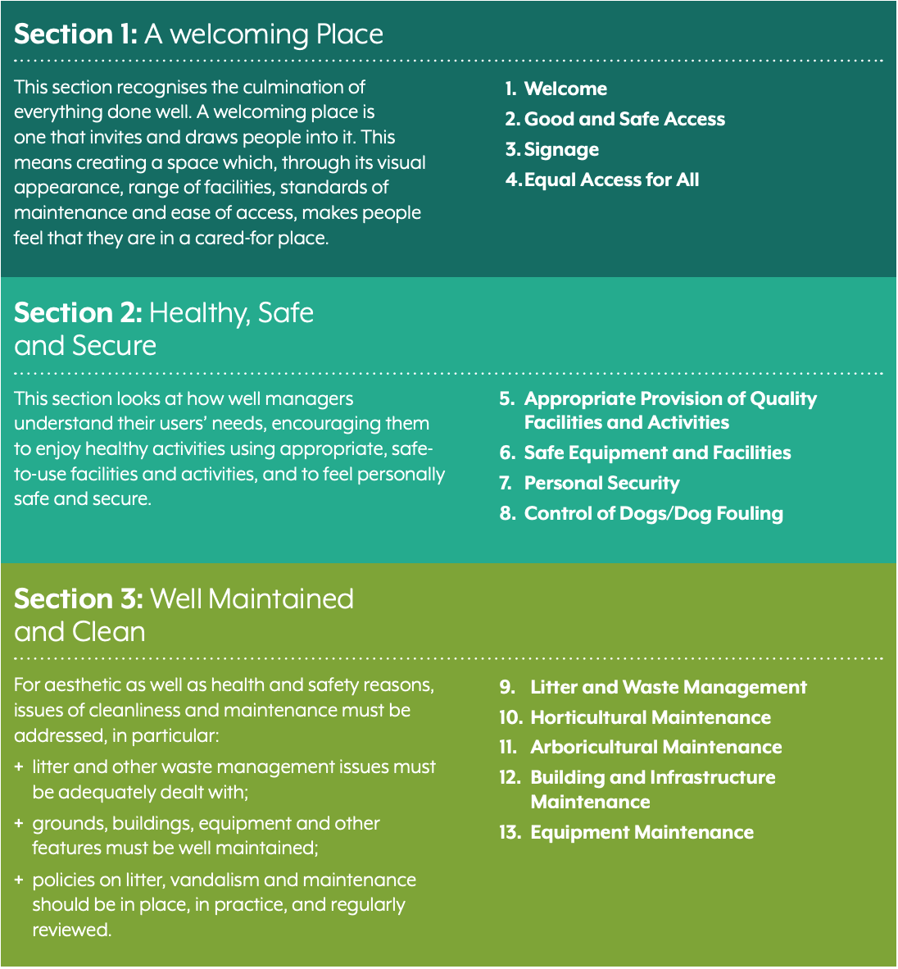
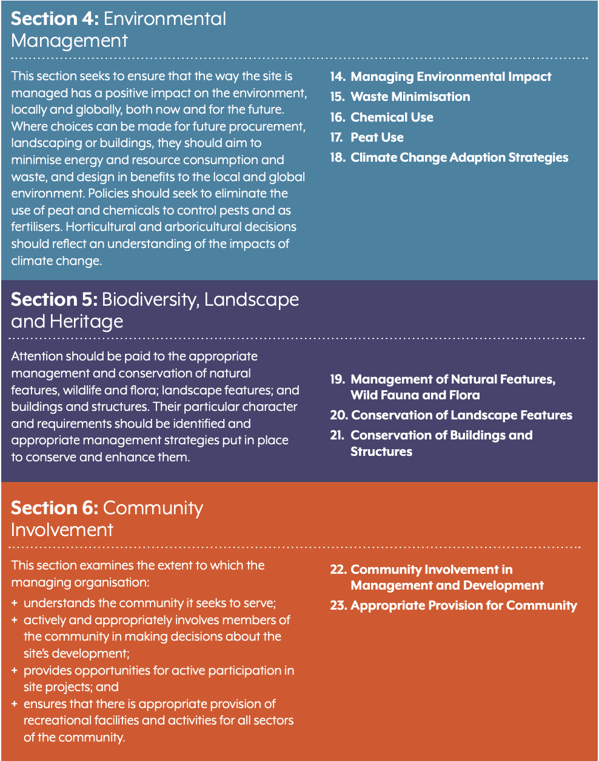
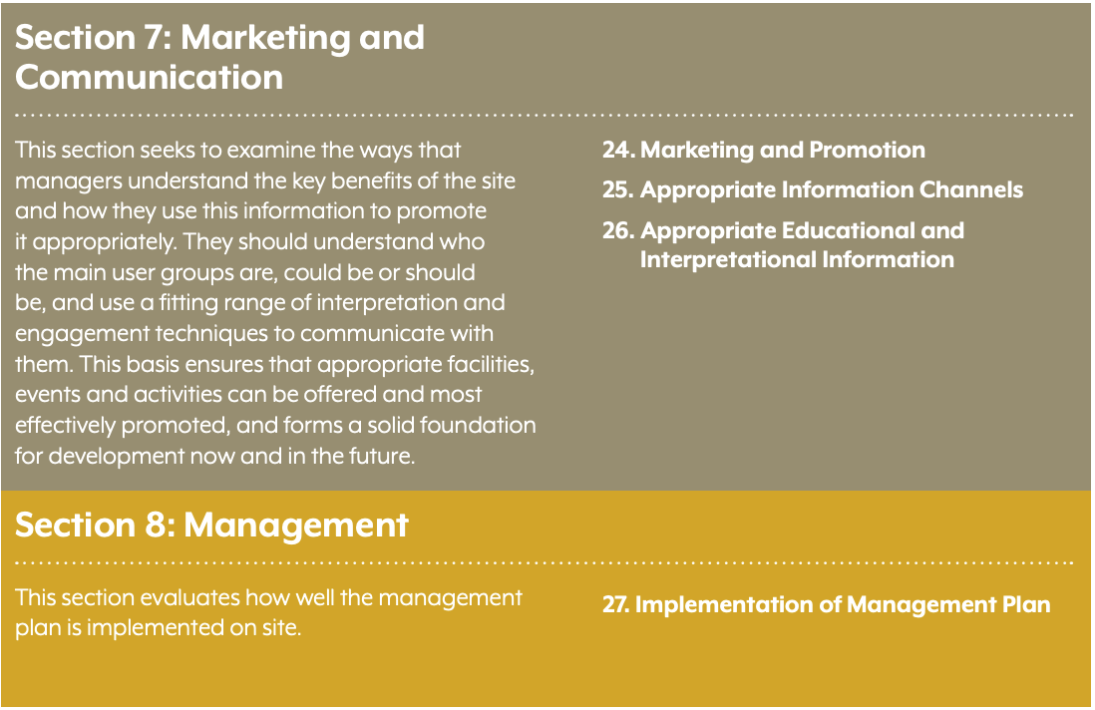

Appendix 2e: Gedling Borough site quality assessment
Summary of Site Inspections by Scores & Gap in Quality of Provision (Summer 2010 Assessment)
APSE Classification | Site Location | Site Score | Potential Score | Difference (Gap) | No. of Assessment Criteria | Average Site Score divided by Assessment Criteria | Average x 7 to get Green Flag Score | Pass
C | Breckhill | 139 | 187 | 48 | 25 | 5.6 | 39 | Fail
B | Arnot Hill Park | 226 | 241 | 15 | 27 | 8.4 | 59 | Pass
C | Arno Vale Road | 116 | 141 | 25 | 19 | 6.1 | 43 | Pass
B | Burntstump CP | 159 | 191 | 32 | 24 | 6.6 | 46 | Pass
B | KGV Standhill | 147 | 173 | 26 | 23 | 6.4 | 45 | Pass
C | Carlton Hill Rec | 136 | 157 | 21 | 22 | 6.1 | 43 | Pass
C | Cavendish Road | 113 | 136 | 23 | 20 | 5.6 | 39 | Fail
C | Church Lane | 153 | 182 | 29 | 23 | 6.6 | 46 | Pass
B | Colwick Rec | 148 | 164 | 16 | 23 | 6.4 | 45 | Pass
B | Conway Road | 136 | 159 | 23 | 24 | 5.7 | 40 | Fail
C | Jackie Bells | 141 | 156 | 15 | 22 | 6.4 | 45 | Pass
B | Burton Road | 128 | 166 | 38 | 23 | 5.6 | 39 | Fail
C | Killisick Rec | 139 | 163 | 24 | 23 | 6.0 | 42 | Pass
B | KGV Arnold | 125 | 156 | 31 | 21 | 5.9 | 41 | Fail
B | Lambley Lane (N) | 140 | 171 | 31 | 25 | 5.6 | 39 | Fail
B | Lambley Lane (S) | 121 | 154 | 33 | 23 | 5.2 | 36 | Fail
C | Newstead | 124 | 141 | 17 | 20 | 6.2 | 43 | Pass
B | Oakdale Road | 175 | 210 | 35 | 26 | 6.7 | 47 | Pass
C | Thackerays Lane | 138 | 163 | 25 | 24 | 5.7 | 40 | Fail
C | Queensbower | 129 | 138 | 9 | 20 | 6.4 | 45 | Pass
60% in the field evaluation (score 42 out of 70). Score over 42 to gain a pass.

Appendix 3
Natural and Semi Natural Green Space
Site audit of Natural and Semi-Natural green space
Site Name | Size (ha) | Definition | Ward | Location
Loop Road Wood, rear of Chandos St Allotments. | 0.9 | Other | Netherfield and Colwick Ward | Urban
The Hobbucks | 14 | LNR | Killisick ward | Urban
Woodborough Conservation Areas | 1.3 | Other | Woodborough Ward | Rural
Surgeys Lane | 0.1 | Other | St. Mary's Ward | Rural
Netherfield Lagoons | 51.0 | LNR | Burton Joyce and Stoke Bardolph Ward | Rural
Emmanuel Avenue (Churchfield Plantation) | 0.2 | Other | Porchester Ward | Rural
Beeston Close | 0.7 | Other | Bestwood Village Ward | Rural
Gedling House Woods and Meadow | 7.0 | LNR | Gedling Ward | Urban
Ashwell Street / Bourne Street Walkway | 0.1 | Other | Netherfield and Colwick Ward | Urban
Ravenhead Knoll | 0.4 | SINC | Ravenshead Ward | Rural
Longdale Plantation | 28.3 | SINC | Cavlerton Ward | Rural
Longdale Heath | 1.5 | SINC | Ravenshead Ward | Rural
Fox Covert | 8.5 | SINC | Ravenshead Ward | Rural
Raceground Hill | 7.5 | SINC | Bestwood Village Ward | Rural
Mill Pond Plantation | 3.9 | SINC | Bestwood Village Ward | Rural
Cornwalls Hill Grassland | 1.7 | SINC | Bestwood Village Ward | Rural
Stockhill Grasslands, Lambley | 6.7 | SINC | Lambley Ward | Rural
Burton Joyce Pasture | 5.7 | SINC | Burton Joyce and Stoke Bardolph Ward | Rural
The Woodpeckers, Burton Joyce | 0.9 | SINC | Burton Joyce and Stoke Bardolph Ward | Rural
Burton Joyce Grasslands | 3.6 | SINC | Burton Joyce and Stoke Bardolph Ward | Rural
Burton Joyce Scrub | 3.2 | SINC | Burton Joyce and Stoke Bardolph Ward | Rural
Crock Dumble | 5.2 | SINC | Burton Joyce and Stoke Bardolph Ward | Rural
Barrons Plantation with Gedling Wood | 6.2 | SINC | Gedling Ward | Urban
Harveys Plantation Meadow | 1.1 | SINC | Gedling Ward | Urban
New Plantation, Burton Joyce | 9.4 | SINC | Burton Joyce and Stoke Bardolph Ward | Rural
Lambley Dumble Grassland | 7.8 | SINC | Lambley Ward | Rural
Lambley Dumble Pasture | 3.5 | SINC | Lambley Ward | Rural
Lambley Dumble | 3.0 | SINC | Lambley Ward | Rural
Marshy Grasslands, Lambley | 2.7 | SINC | Lambley Ward | Rural
Catfoot Lane Grassland | 2.9 | SINC | Lambley Ward | Rural
Fox Covert Grasslands, Lambley | 0.7 | SINC | Lambley Ward | Rural
Grassland / Hedge, Lambley | 1.3 | SINC | Lambley Ward | Rural
Mapperley Plains Paddocks | 1.5 | SINC | Lambley Ward | Rural
Fox Wood | 3.8 | SINC | Lambley Ward | Rural
Grassland (Horse Grazed), Calverton | 0.7 | SINC | Calverton Ward | Rural
Lamp Wood | 5.7 | SINC | Calverton Ward | Rural
Georges' Lane Scrub | 0.6 | SINC | Calverton Ward | Rural
Bestwood Sand Quarry | 22.8 | SINC | Bestwood Village Ward | Rural
Trumpers Park Wood | 4.0 | SINC | Ravenshead Ward | Rural
Linby Village Disused Railway | 2.1 | SINC | Newstead Ward | Rural
Joes Wood | 1.4 | SINC | Newstead Ward | Rural
Aldercar Wood | 11.6 | SINC | Newstead Ward | Rural
Linby - Newstead Disused Railway | 3.6 | SINC | Newstead Ward | Rural
Calf Pasture | 10.9 | SINC | Newstead Ward | Rural
Break Lane | 0.5 | SINC | Newstead Ward | Rural
Seven Mile Railway | 4.6 | SINC | Newstead Ward | Rural
Calverton Pit Mineral Railway | 8.3 | SINC | Calverton Ward | Rural
Lodge Farm Grassland, Calverton | 1.5 | SINC | Calverton Ward | Rural
Roadside Verge, Calverton | 0.6 | SINC | Calverton Ward | Rural
Little Rickets Lane Scrub | 2.9 | SINC | Calverton Ward | Rural
Newstead Dismantled Railway Sidings | 9.2 | SINC | Newstead Ward | Rural
Linby Paddock | 0.7 | SINC | Newstead Ward | Rural
Wighay Road Grassland | 3.3 | SINC | Newstead Ward | Rural
Moor Pond Wood | 5.7 | SINC | Newstead Ward | Rural
Top Wighay Farm Drive | 0.6 | SINC | Newstead Ward | Rural
Bestwood Duckponds | 18.1 | SINC | Bestwood Village Ward | Rural
North Dumble | 1.0 | SINC | Bestwood Village Ward | Rural
Bestwood Parkside Grasslands | 20.8 | SINC | Bestwood Village Ward | Rural
Pit Tip Top Plantation | 25.0 | SINC | Bestwood Village Ward | Rural
Former Gedling Colliery Land | 35.1 | SINC | Gedling Ward | Rural
Appleton Dale | 7.5 | SINC | Gedling Ward | Rural
Dark Lane, Calverton | 0.7 | SINC | Calverton Ward | Rural
Burton Joyce Cemetery | 0.8 | SINC | Burton Joyce and Stoke Bardolph Ward | Rural
Bestwood Country Park | 62.8 | SINC | Bestwood Village Ward | Rural
Woodborough Cemetery | 0.4 | SINC | Woodborough Ward | Rural
Linby Churchyard | 0.4 | SINC | Newstead Ward | Rural
Newstead Football Pitch | 1.1 | SINC | Newstead Ward | Rural
Newstead Cemetery | 0.5 | SINC | Newstead Ward | Rural
Carlton Cemetery | 5.1 | SINC | Valley Ward | Urban
Linby Quarries | 55.1 | SINC | Newstead Ward | Rural
Gedling Cemetery | 0.7 | SINC | Gedling Ward | Rural
Midland Wood (Whimsy Park) | 16.2 | Other | Netherfield and Colwick Ward | Urban
Total | 548.9

It must be noted that a number of sites with elements of natural and semi natural green space were not included in the audit due to them not being classified as SINCs and having another primary function. For example, this includes land categorised under the typology parks and gardens such as Burntstump Country Park.

Appendix 4
Amenity Green Space
Site audit of amenity green space
Site Name | Size (ha) | Ward | Location
Bestwood Avenue/Close | 0.61 | Bonington Ward | Urban
Bestwood Lodge Drive Estate | 6.21 | Bonington Ward | Urban
Bewcastle Road | 0.03 | Bonington Ward | Urban
Ernehale Court | 0.10 | Bonington Ward | Urban
Larkspur Avenue/ Lodge Farm | 0.01 | Bonington Ward | Urban
Muirfield Road | 0.66 | Bonington Ward | Urban
Stanhope Crescent | 0.10 | Bonington Ward | Urban
Woodchurch Road Bestwood | 1.00 | Bonington Ward | Urban
Bramble Drive (Honeywood Gardens) | 0.01 | Carlton Hill Ward | Urban
Cherrywood Gardens | 0.09 | Carlton Hill Ward | Urban
Foxhill Road | 0.17 | Carlton Hill Ward | Urban
Holly Avenue/ Cross St. Carlton | 0.03 | Carlton Hill Ward | Urban
Honeywood Garden | 2.22 | Carlton Hill Ward | Urban
Standhill Road Flats | 0.10 | Carlton Hill Ward | Urban
Carlton Business Centre | 0.04 | Carlton Ward | Urban
Carlton Hill Flats | 0.37 | Carlton Ward | Urban
Carlton Square Offices | 0.01 | Carlton Ward | Urban
Cromwell St Flats/ Walton Court | 0.24 | Carlton Ward | Urban
Moreland Court | 0.22 | Carlton Ward | Urban
Orchard Avenue | 0.01 | Carlton Ward | Urban
Southdale Drive | 0.09 | Carlton Ward | Urban
Bagnall Avenue Hostel | 0.05 | Daybrook Ward | Urban
Byron Street/ Wordsworth Street | 0.03 | Daybrook Ward | Urban
Coleridge Cresecnt | 0.13 | Daybrook Ward | Urban
Danes Close | 0.05 | Daybrook Ward | Urban
Nottingham Road Flats | 0.12 | Daybrook Ward | Urban
Queensbower Road / Bestwood Lodge Drive | 2.10 | Daybrook Ward | Urban
Seagrave Court | 0.01 | Daybrook Ward | Urban
St Albans Road Flats/ Furlong St Flats | 0.05 | Daybrook Ward | Urban
St. Albans Road Flats | 0.02 | Daybrook Ward | Urban
Top Valley, Oxclose Lane | 0.58 | Daybrook Ward | Urban
West Street/ High Street Avenue | 0.07 | Daybrook Ward | Urban
Bramble Court | 0.19 | Gedling Ward | Urban
Brooklands Drive | 0.13 | Gedling Ward | Urban
Burton Pastures | 0.60 | Gedling Ward | Urban
Burton Road Burton Joyce | 4.15 | Gedling Ward | Urban
Conway Road | 0.85 | Gedling Ward | Urban
Coronation Walk Bungalows | 0.14 | Gedling Ward | Urban
Coronation Walk/Burton Road | 0.22 | Gedling Ward | Urban
Saltford Close | 0.14 | Gedling Ward | Urban
St. Austin's Court | 0.10 | Gedling Ward | Urban
Bonnington Drive Flats | 0.04 | Killisick Ward | Urban
Brook Avenue | 0.50 | Killisick Ward | Urban
Kilbourne Road | 4.29 | Killisick Ward | Urban
Killisick Court | 0.22 | Killisick Ward | Urban
Kilnbrook Avenue | 0.06 | Killisick Ward | Urban
Oakdale Road | 0.09 | Killisick Ward | Urban
Taverhillfield Court, Kilnbrook Ave | 0.02 | Killisick Ward | Urban
Brookfield Road | 1.28 | Kingswell Ward | Urban
Brookfield Road Flats | 0.05 | Kingswell Ward | Urban
Downham Close | 0.21 | Kingswell Ward | Urban
Gedling Grove Flats | 0.14 | Kingswell Ward | Urban
Arnold Hill Community Centre | 0.01 | Mapperley Plains Ward | Urban
Edison Way Square | 0.08 | Mapperley Plains Ward | Urban
Howbeck Road/ Gleneagles Drive | 0.11 | Mapperley Plains Ward | Urban
Spinningdale Open Space | 0.57 | Mapperley Plains Ward | Urban
Wemberley Road/ Plains Road Open Space | 1.93 | Mapperley Plains Ward | Urban
Bailey Court | 0.03 | Netherfield and Colwick Ward | Urban
Bourne Mews | 0.46 | Netherfield and Colwick Ward | Urban
Britannia Court | 0.14 | Netherfield and Colwick Ward | Urban
Curzon Street Flats | 0.09 | Netherfield and Colwick Ward | Urban
Curzon Street/Ley Street | 0.02 | Netherfield and Colwick Ward | Urban
Hotspur Drive | 0.25 | Netherfield and Colwick Ward | Urban
Kingsley Drive / Rochester Avenue | 0.02 | Netherfield and Colwick Ward | Urban
Kingsley Drive Open Space | 0.96 | Netherfield and Colwick Ward | Urban
Ley Street Community Centre | 0.02 | Netherfield and Colwick Ward | Urban
Meadow Road Flats | 0.05 | Netherfield and Colwick Ward | Urban
Charles Close | 0.16 | Phoenix Ward | Urban
Phoenix Avenue Recreation Ground | 0.29 | Phoenix Ward | Urban
Princess Close | 0.07 | Phoenix Ward | Urban
Oxclose Lane Estate | 0.16 | Sherwood Ward | Urban
Beck Street/Worth Street Flats | 0.05 | Valley Ward | Urban
Bentinick Road | 0.16 | Valley Ward | Urban
Cavendish Crescent | 0.03 | Valley Ward | Urban
Foxhill Road Flats | 0.01 | Valley Ward | Urban
Foxhill Road/ Cavendish Road Footpath | 0.02 | Valley Ward | Urban
Ian Grove | 0.03 | Valley Ward | Urban
Radcliffe Gardens | 0.02 | Valley Ward | Urban
Woodthorpe Drive | 0.12 | Woodthorpe Ward | Urban
Church Road / Chestnut Grove Play Area | 0.47 | Burton Joyce and Stoke Bardolph Ward | Rural
Lendrum Court | 0.51 | Burton Joyce and Stoke Bardolph Ward | Rural
Stoke Bardolph | 0.27 | Burton Joyce and Stoke Bardolph Ward | Rural
Stoke Lane/Station Road | 0.83 | Burton Joyce and Stoke Bardolph Ward | Rural
Broom Road | 0.28 | Calverton Ward | Rural
Calverton Open Space | 1.64 | Calverton Ward | Rural
Collyer Road / Mews Lane | 0.01 | Calverton Ward | Rural
Dunelm Drive | 2.36 | Calverton Ward | Rural
Governors Field, Main Street | 1.90 | Calverton Ward | Rural
Jumelles Drive / Longue Drive | 0.31 | Calverton Ward | Rural
Lee Road | 0.07 | Calverton Ward | Rural
Lee Road Rec Ground | 0.70 | Calverton Ward | Rural
Manor Road Garages Calverton | 0.29 | Calverton Ward | Rural
Nabarro Court Calverton | 0.37 | Calverton Ward | Rural
Renals Way / Brickenell Road | 0.23 | Calverton Ward | Rural
Seely Avenue | 0.46 | Calverton Ward | Rural
Spindle View | 0.20 | Calverton Ward | Rural
Thorndale Road / Park Road | 0.37 | Calverton Ward | Rural
Coppice Road/ Mapperley Plains | 0.05 | Lambley Ward | Rural
Cromwell Crescent Lambley | 0.04 | Lambley Ward | Rural
Hucknall Road Recreation Ground | 1.09 | Newstead Ward | Rural
Linby Village | 0.04 | Newstead Ward | Rural
Newstead Colliery Open Space, Tilford Road | 3.07 | Newstead Ward | Rural
Papplewick Moor Road | 1.00 | Newstead Ward | Rural
Rear of Griffins Head | 0.17 | Newstead Ward | Rural
Plains Road Mapperley, Mapperley Miners Welfare Cl | 0.97 | Porchester Ward | Urban
St. Andrew's House, Digby Avenue | 0.21 | Porchester Ward | Urban
Westdale Lane Community Centre | 0.09 | Porchester Ward | Urban
Westmoore Close Housing Area | 0.45 | Porchester Ward | Urban
Westmoore Court | 0.18 | Porchester Ward | Urban
Haddon Road | 0.18 | Ravenshead Ward | Urban
Cavendish Road Bungalows | 0.04 | St. James Ward | Urban
Orchard Court | 0.22 | St. James Ward | Urban
Wollaton Avenue Community Centre | 0.05 | St. James Ward | Urban
Asda Shrubbery (High Street) | 0.02 | St. Mary's Ward | Urban
Calverton Road | 0.21 | St. Mary's Ward | Urban
Church Lane Flats | 0.07 | St. Mary's Ward | Urban
Church Street/Coppice Road Flats | 0.06 | St. Mary's Ward | Urban
Rookery Gardens | 0.31 | St. Mary's Ward | Urban
St Mary’s Church/Rest Garden | 0.75 | St. Mary's Ward | Urban
St Marys Close Flats | 0.02 | St. Mary's Ward | Urban
Rushcliffe Avenue Community Centre | 0.02 | Valley Ward | Urban
Park Avenue Woodborough | 0.01 | Woodborough Ward | Urban
Smalls Croft | 0.33 | Woodborough Ward | Urban
Marshall Hill Drive, Carlton Hill | 2.00 | Carlton Ward | Urban
Arnold Vale road | 1.40 | Woodborough Ward | Urban
Rural Total | 16.73ha
Urban Total | 42.40ha
Overall Total | 59.13ha

Appendix 5
Provision for Children and Young People
Appendix 5a: The main characteristics of LAPs, LEAPs and NEAPs

 | Local Area for Play | Locally Equipped Area for Play | Neighbourhood Equipped Area for Play
Age group | Up to 6 years. | 4-8 years. | Older children.
Walking time from home | 1 minute. | 5 minutes. | 10 minutes.
Location | Adjacent to a well-used pathway, overlooked by houses and on a flat site that is well drained. | Adjacent to a well-used pathway and on a flat site that is well drained. | Adjacent to a well-used pathway and on a flat site that is well drained.
Minimum activity zone | 100m². | 400m². | 1,000m² divided into 2 parts; at least 465m² of hard surface area and equipped play space area.
No. and type of play equipment | Demonstrative play features to enable children to identify space as their own domain. | At least 5 types of play equipment where at least 2 are individual items rather than part of a combination. Impact absorbing surface beneath and around play equipment. | At least 8 types of play equipment to allow developmental play amongst younger children and moderate/adventurous play for older children.
Buffer zone | 5m depth including planting. | 10m depth including planting and other physical features. | 30m depth including planting and other physical features.
Fencing | 600mm high fencing and barrier to limit speed of child entering or leaving the facility. | 1m high fencing with two pedestrian gates & barriers to limit speed of child entering/leaving the facility. | 1m high fencing with two pedestrian gates & barriers to limit speed of child entering/leaving the facility.
Furniture | Seating. | Seating and a litter bin. | Seating and litter bins at each access point. Secure bicycle parking facilities.
Signs and notices | Area solely used for children and that adults are not allowed unless accompanied by children. | Area solely used for children and that adults are not allowed unless accompanied by children, and name and tel. no. of facility manager. | Area solely used for children and that adults are not allowed unless accompanied by children, and name and tel. no. of facility manager.

Appendix 5b: Play Value pro forma (Derived from Play England and ROSPA)
Site Name: |  | Number of pieces of equipment: |  |  |  | Weather:
Assessment By: |  | Date:
Toddlers |  |  |  |  | Juniors
Criteria | No. of pieces of equipment | Max | Score |  | Criteria | No. of pieces of equipment | Max | Score
Balancing |  | 1 |  |  | Balancing |  | 2
Crawling (Short tunnels etc) |  | 1 |  |  | Crawling (Short tunnels etc) |  | 1
Hiding |  | 1 |  |  | Rocking |  | 1
Climbing |  | 1 |  |  | Rotating |  | 1
Jumping/bouncing |  | 1 |  |  | Rotating (Multi-use i.e., roundabouts etc) |  | 2
Rolling |  | 1 |  |  | Rocking and rotating (Mobilus, Waltz etc) |  | 4
Rocking |  | 1 |  |  | Sliding conventional (i.e., slide etc) |  | 1
Rotating |  | 1 |  |  | Sliding (Fireman’s pole etc |  | 1
Sliding |  | 1 |  |  | Swinging (Single) |  | 1
Swinging |  | 1 |  |  | Swinging (Group) |  | 2
Sensory Items (sight, smell and sound) Traffic is negative. |  | 3 |  |  | Gliding (Aerial runways etc) |  | 2
Textural Variety (two types of material = 1, three types plus = 2) |  | 2 |  |  | Hanging |  | 1
3+Primary Colours (bold colours) |  | 2 |  |  | Climbing (ladders, climbing wall and net) |  | 3
Toddler Seating |  | 1
Does it lend to Imaginative play? Score relates to number of items that allow for imaginative play 0 >1=1, 2>3= 2, 3+=5 |  | 5 |  |  | Agility (Clatter bridges etc) |  | 2
Interactive ability (Items encouraging group) pieces of equipment 1 or 2=1,3 or 4=2, 5+3 |  | 3 |  |  | Ball Play (Basketball/netball/football) when encouraging competition more marks |  | 4
Parental Seating (in Toddler section) |  | 1 |  |  | Textural Variety (two types of material = 1, three types plus = 2) manipulate natural and fabricated  materials |  | 2
Total |  | 27 | 0
Teenagers |  |  |  |  | Wheeled Play (for bikes, skateboards etc) flow, mix of obstacles and terrain |  | 6
Criteria | No. of pieces of equipment | Max | Score |  | 3+ Primary colours |  | 1
Interaction - Number of items which allow for group play. 4=4 marks 1=1mark etc |  | 4 |  |  | Interactive ability (Items encouraging group) pieces of equipment 1 or 2 =1 3or 4=2 5+3 |  | 3
Sports Simulation / Dynamic Equipment / Competition. Site caters for 1 sport site caters for more than one sport, site allows for competition, equipment is multi use |  | 4 |  |  | Junior Seating |  | 1
Fitness equipment 4= broad range of fitness equipment including cardio and muscular items 3 = less than 6 items but cardio and muscular present 2= only one type of equipment present but more than 1 in quantity 1= one piece of equipment |  | 4 |  |  | Imaginative play (Area lending to use of child’s imagination, floor graphics, pretend play, local connection) |  | 4
Rocking and rotating (Mobilus, Waltz etc) one mark for Rocking, one for rotating, an extra mark if there is more than 1 item. |  | 4 |  |  | Educational Play (abacus etc) |  | 1
Swinging (Group) Up to two marks for a basket swing, up 2 marks for a rope swing 1-2 marks depends on quality |  | 4 |  |  |  |  | 48 | 0
Gliding (1 = glide rail, 2= small to medium sized Aerial runways 3 = large aerial runway) |  | 3 |  |  | SITE ASSESSMENT
Climbing (Climbing walls etc) 1= climbing present 2= Climbing applicable for all ages |  | 2 |  |  | Criteria | Max | Details | Score
Textual variety 1-2 materials used =1 3+ is two marks. manipulate natural and fabricated  materials |  | 2 |  |  | Physical Safety, including secure boundary, vandalism, personal safety, maintenance e of equipment, feeling of safety | 5 | Overlooked CCTV, self-closing gate
Graphics - one mark each of these: graphics present, children involved in producing it, use of bright colour |  | 3 |  |  | Minimum of two gates and self-closing | 2
Teenage Seating areas/shelters. Seating - 1 mark for good location, 1 mark for seat rests, 1 mark for normal seating. Shelter -1 mark for a shelter present, 1 mark for good location of shelter, 1 mark for panels |  | 6 |  |  | Access suitable for pushchairs and wheelchairs ( | 2 | one mark for gates being DDA compliant and one for level access)
Ball Play number of sports (football, basketball/netball, cricket) 1 mark line markings, 2 marks surface condition, |  | 6 |  |  | Age separation | 3 | clearly defined area which allows Children to easily transfer areas
Wheeled Play (for bikes, skateboards etc) 2 marks for ancillary facilities e.g. seating area, 2 marks for flow, 2 marks for mix of obstacles and terrain |  | 6 |  |  | Access for disabled (in reference to activities provided by equipment) | 3 | 1=1-2, 2=3-4, 3=5+
Total |  | 48 | 0 |  | Adult Seats | 1
 |  |  |  |  | Bike storage | 1
 |  |  |  |  | Suitable litter bins | 1
 |  |  |  |  | appropriate signage | 1
Is the play area well used? | 1= not 5=very well used | 5 |  |  | Layout? location is a part of the throughfare, and location in area | 2
 |  |  |  |  |  | 21

Appendix 6
Outdoor Sports Facilities
Gedling Borough Playing Pitch Strategy and action plan
An update of the Playing Pitch Strategy is currently being prepared for republication in 2021. The information provided below will inform the new Playing Pitch Strategy and is the latest information the council holds about the outdoor sports facilities in the borough.
Site  ID | Site | Sport | Management | Current status | Recommended actions | RAG | Comment | Timescales
5 | Arnold Hill Academy | Football | Trust/  Academy | Two adult football pitches on different levels of the two-tiered site. One pitch has been unused following Sport England investment towards pitch improvement work but is due to be operational for the beginning of the next school year. The other standard quality pitch is on the lower level and is used mainly for school fixtures given most curricular sport takes place on the Playfootball Nottingham 3G pitches on the shared site. This pitch is likely to be overplayed. The school is currently undergoing redevelopment which includes the provision of new pitches.  Update: 20.06.17  Gedling Southbank FC to have 20 teams playing on this site from season 2017/18 following the development of new pitches.  Update: 11.01.19  Additional grass pitches will be available soon both community and school use soon. Their remains a drainage issue regarding this new provision that the Academy is seeking to resolve with the contractor. This poses an uncertainty whether these pitches will be available for the 2019/20 football season. When pitches become available it is expected they will meet the grow demand of Gedling Southbank junior teams and the facility will provide a 7x7 and 9x9.  The Academy is currently assessing quality issues regarding the existing new provision on site referred to in Update 20.06.17.  The Academy has continued concerns regarding the poor quality of the 3G pitch provision currently managed by Play Football. | Maximise use of the newly improved for use by school teams supported by continued use of the 3G pitches.  Improve pitch quality through increased maintenance, creating additional capacity to reduce likely overplay on the bottom pitch.  Explore potential to access newly developed provision for community use to increase capacity and reduce shortfalls. |  | Local site | Short
 |  | Rugby union |  | Poor (M0/D1) quality senior pitch unavailable for use due to ongoing construction work onsite. New school build in progress to include the re-provision of lost grass pitches. Intentions to make grass pitches available for use again when building work is completed in two- or three-years time.  Update: 11.01.19  The Academy has plans for the new grass pitches to offer rugby goals initially for school use. | Improve pitch quality through increased maintenance, creating additional capacity to reduce likely overplay on the bottom pitch.  Explore potential to access newly developed provision for community use to increase capacity and reduce shortfalls at club sites. |  |  | Short
6 | Arnot Hill Park | Bowls | GBC | Standard quality green used by Arnold Park BC. The Club has around 30 members, therefore the green is considered to have spare capacity to accommodate additional members and play.  Update 11.01.19  We believe the membership of Arnold Park BC has reduced. Therefore spare capacity exists on this site. | Improve standard of maintenance to improve green quality.  Determine future plans for sporting use of the site given potential need to rationalise supply amidst budget pressures.  Consider potential for asset transfer and club management mechanism where viable. |  | Local site | Short
7 | Bestwood Country Park | Football | County Council | Mini 7v7 pitch and two adult pitches, one of which is overmarked with a youth 9v9 pitch. Pitches are standard quality and used by six teams from Bestwood Park Rangers Youth FC. Pavilion building is too small and the Club has to use all available space including changing rooms as storage space which becomes dangerous. Actual spare capacity of one mini 7v7 match per week.  Update: 20.06.17  Following the Football Development Group meeting on 19.06.17, Bestwood Park Rangers Youth FC reported they have reduced to 3 teams.  Update 16.12.19  The pitches are currently being used and booked by NG United providing junior and youth Football on the site. | Remove overmarked youth 9v9 pitch and seek to make greater use of spare capacity elsewhere or on certified 3G pitches to re-accommodate this competitive demand.  Consider installation of an external storage container so that equipment is not obstructing pavilion facilities.  Update: 20.06.17  Review licence on this site between GBC and Bestwood Park Rangers Youth FC  Update: 17/12/19  Establish relationship between NG United and Bestwood Park Rangers and seek licence renewal. |  | Local site | Medium
 |  | Tennis |  | Two poor quality courts without floodlighting. Available for community use but no recorded club use. Likely used for social and recreational tennis. | Improve quality to increase attractiveness and performance for play.  Seek to maximise use for participation activities such as parks leagues or cardio tennis. |  |  | Short
Site  ID | Site | Sport | Management | Current status | Recommended actions |  | Site hierarchy tier | Timescales
8 | Bestwood Miners Welfare Sports Ground | Football | CISWO/  Trust | Standard quality adult pitch used by just one team from Bestwood Miners Welfare FC. The Club has aspirations to play in the football pyramid at Step 7. Site demand will increase next season by one adult team, whilst the Club also has ambitions for a junior section. Actual spare capacity of 0.5 match sessions per week. | Improve pitch quality through increased maintenance, creating additional capacity to reduce shortfalls.  Maximise use of spare capacity to reduce existing shortfalls.  Support the Club in developing facilities to meet Step 7 requirements. |  | Local site | Short
9 | Bestwood Village Community Centre | Bowls | Parish Council | Good quality green used by Bestwood Workshops BC and Star BC. Membership unknown, however, the green is considered to have spare capacity for additional membership and play. | Maximise use of spare capacity through club development and increasing participation. |  | Local site | Short
 |  | AGP |  | Two small sized sand-based pitches with floodlighting which are now disused. The pitches are partly dismantled and cannot be played on but Bestwood Miners Welfare FC states that it would like to be a part of any community scheme that could bring these pitches back into use and is investigating possible funding opportunities that might enable them to be.  Update: 01.11.18  Currently no plans to refurbish the former pitches, which are currently an eyesore for the local community. Recent health and wellbeing programme in the village identifies this as a priority, but there is insufficient funding and capacity in the community to move this forward. The biggest priority regarding facilities for the community at present is pursuing a healthcare facility. | Support the Club as appropriate and consider potential for resurfacing to 3G as a more appropriate surface to accommodate football use and to meet shortfalls. |  |  | Medium
10 | Oakwood Academy | Football | Trust/  Academy  PFI | Two standard quality youth 11v11 pitches available for community use. No recorded community use at present but likely to be overplayed given the extent of academy use for lessons and fixtures throughout the week. | Retain for school use and explore potential for increased future community use to help reduce shortfalls. |  | Local site | Short
 |  | Rugby union |  | Poor (M0/D1) quality pitch maintained by Carillion to a basic standard. Available for community use and previously well used before PFI but the academy believes that community use would require covering of staffing costs which is cost prohibitive for most teams. Likely to be overplayed given the level of weekly academy use. | Improve pitch quality through increased maintenance, creating additional capacity for school use.  Work to resolve barriers to community use, particularly cost of hire and access to changing provision. |  |  | Short
 |  | Cricket |  | Non turf pitch situated between football pitches which has now become disused. | Maximise school use and resurface if required for school use given no demand for community use. |  |  | Short
 |  | AGP |  | Small sized sand filled AGP rated as standard quality with floodlighting. Available for community use but not recorded as being used. Marked with three tennis courts and used for tennis and small sided football. | Maximise community use to accommodate demand for team training. |  |  | Short

Appendix 7
Allotments and Community Gardens
Allotment Facilities
Site name | Water | Toilets | Sheds | Fencing | Recycling | Access | Skips | Car park | Plot watch
Leapool | YES | NO | YES | YES | NO | YES | NO | YES | NO
Stoke Lane | YES | NO | NO | NO | NO | YES | NO | YES | NO
Chandos | YES | NO | NO | NO | YES | NO | YES | YES | NO
Gedling Grove | YES | NO | NO | YES | NO | YES | YES | YES | YES
Howbeck Allotment site | YES | NO | NO | YES | NO | YES | NO | NO | NO
Killisick Allotment | YES | NO | NO | YES | NO | YES | NO | NO | NO
Rookery Gardens | YES | NO | NO | YES | NO | YES | NO | NO | NO
New Robin Hood | YES | YES | YES | YES | NO | YES | NO | YES | NO
Parish Managed
Trent Lane | YES | NO | NO | NO | NO | YES | YES | NO | NO
Newstead | NO | NO | YES | NO | YES | YES | NO | YES | NO
Calverton | YES | NO | NO | YES | NO | YES | YES | YES | NO
Woodborough | YES | NO | YES | NO | NO | NO | NO | NO | NO

Appendix 8
Cemeteries and Churchyards
Ethnicity of Gedling Borough
The ethnic origin of the population affects demand for burial space. People of Black African and Caribbean origin typically prefer burial, whereas people of Asian, Indian origin typically prefer cremation. This reflects the predominant religious beliefs in these cultures. The graph below shows a comparison of the ethnicity of residents in Gedling and the whole of England and Wales:

Ethnicity of Gedling Borough and England and Wales from ONS 2011 (excluding white British who comprise 80.5% of England and Wales and 90.3% of Gedling’s population)

It can be seen that the population of Gedling borough is less ethnically diverse than England and Wales as a whole. Gedling borough most closely mirrors England and Wales as a whole in the Black Caribbean group, who prefer burial to cremation.

Timescales: (S) -Short (1-2 years); (M) - Medium (3-5 years); (L) - Long (6+ years).
Timescales: (S) -Short (1-2 years); (M) - Medium (3-5 years); (L) - Long (6+ years).

